Constructor
______________________________________________________________________

Q. what is constructor?
________________________________________________________________________
Constructor is a function same name as class name but without return type.

Syntax
_______________________________________________________________________________
class classname{
public:
classname()
{
}
};

Example:
class ABC
{ public:
ABC()//constructor
{
}
};
Q. Why use constructor or what is benefit of constructor?
________________________________________________________________________________
There are two benefits of constructor
1. Call logic when class object created means constructor executes automatically when we create object of class.
2. Constructor is used for to initialize the object: means we can initialize the class member when we create object of class.

Types of constructor
___________________________________________________________________________
1. Default constructor: default constructor means constructor without parameter or no parameter called as default constructor.
Example:
class ABC{
public:
ABC(){ //default constructor
}
};
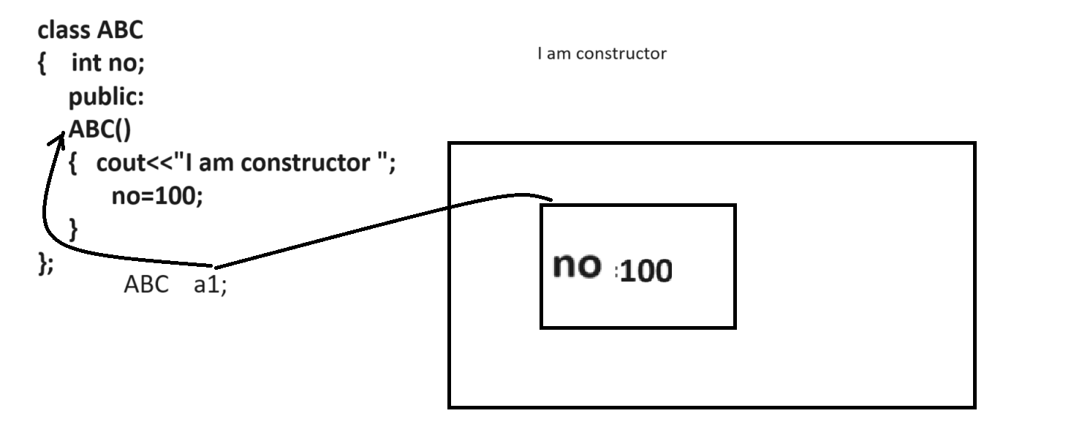
if we think about above diagram we have class name as ABC and we have one default constructor name as ABC and we have object name as ABC a1 means we call constructor ABC automatically and we initialize no=100 means we initialize no value to 100 and no is part of object means we initialize object also.
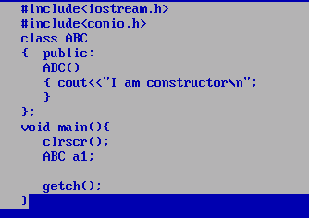
2. Argumented constructor/ parameterized constructor:
___________________________________________________________________________________
Argumented constructor means if we pass parameter to constructor called as argumented constructor
When we pass parameter to constructor we need to pass parameter to object or pass parameter where we create object of class.
Syntax of argumented constructor
class classname{
public:
classname(datatype size,datatype size……..)
{ write here your logics
}
};

Example: Create class name as Square with parameterized constructor and accept number as parameter and calculate its square and return it.
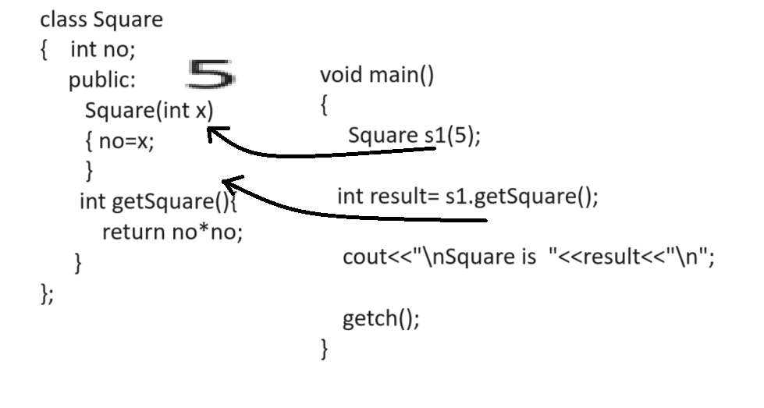
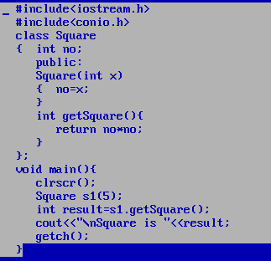

Example: WAP to create class name as Power with parameterized constructor
Power(int base,int index): this constructor accept two parameter one is base and one is index
int getPower(): this function can calculate power and return it.
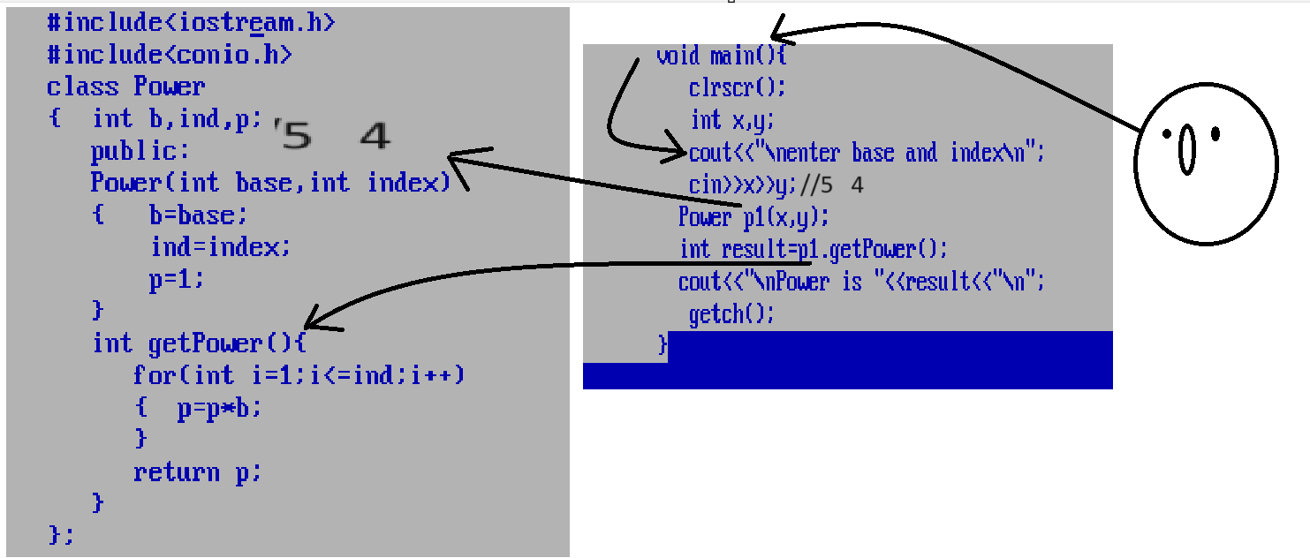
Example: WAP to create class name as Factorial with parameterized constructor
Factorial(int no): this function accept number as parameter
int getFactorial(): this function can calculate factorial and return it.

#include<iostream.h>
#include<conio.h>
class Factorial
{ int no;
public:
Factorial(int no)
{
this->no=no;
}
int getFactorial()
{ int f=1;
for(int i=1; i<=no;i++)
{ f=f*i;
}
return f;
}
};
void main()
{ clrscr();
int no;
cout<<"Enter number\n";
cin>>no;
Factorial f(no);
int result=f.getFactorial();
cout<<"\nFactorial is "<<result;
getch();
}

Example: WAP to create class name as Sum with parameterized constructor
Sum(int a[]): this constructor accept array as parameter of type integer
int getSum(): this function can calculate sum of all array elements and return it.
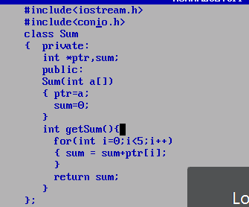
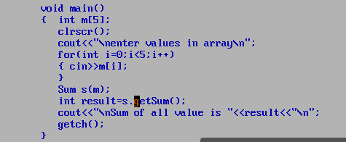

Example: WAP to create class name as UpperCase with parameterized constructor
UpperCase(char[]): this function is used for accept character array as parameter
void toConvertUpper(): this function can lower case string to upper case and display it.

Example: WAP to create class name as FindDifference with parameterized constructor
FindDifference(int a[],int b[]): accept two array as parameter
void findDifference(): this function difference of array and and display it.

Example: WAP to create class name as Reverse with parameterized constructor
Reverse(int no): this function can accept number as parameter
int getReverse(): this function can reverse the number and return it.

Example: WAP to create class name as FindDuplicate with parameterized constructor
FindDuplicate(int a[]): this constructor accept array as parameter
void findDuplicate(): this function can find the duplicated value from array and display it.

3. Overloaded constructor:

Q. What is constructor overloading?
________________________________________________________________________
Constructor overloading means if we have multiple constructor with same name with different parameter with different data type with different parameter sequence called as constructor overloading.
In the case of constructor overloading which constructor should execute is dependent on how much parameter pass in it, its sequence and its data type

Example: we want to create class name as Square with two constructors and calculate square
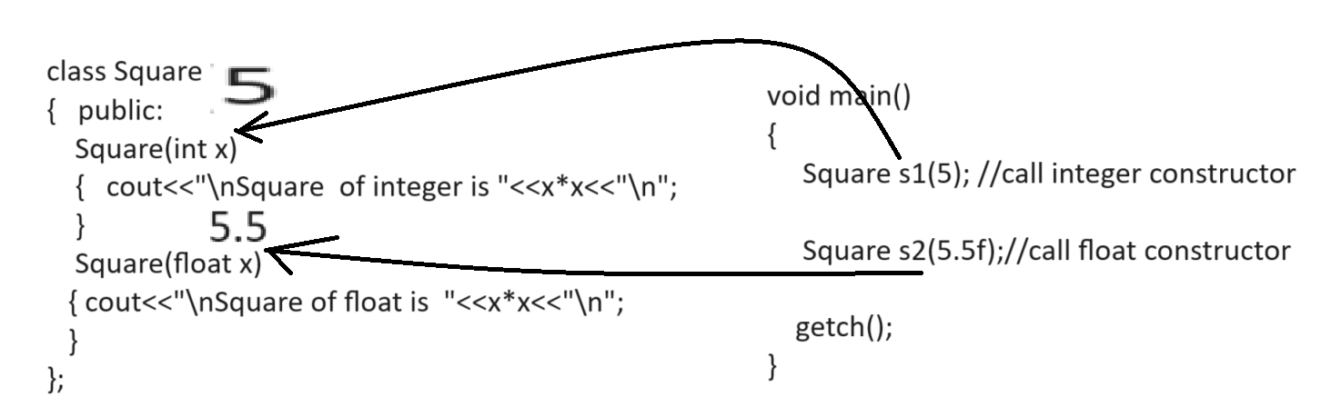
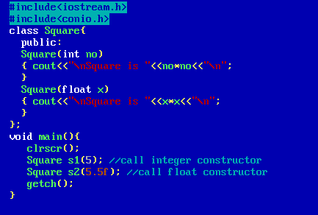

Example: WAP to create class name as Sum with two constructors
Sum(int a[]): this constructor accept integer array as parameter
Sum(float a[]): this constructor accept float array as parameter
int getIntSum(): this function can calculate sum of integer values and return it.
float getFloatSum(): this function can calculate sum of float values and return it.

Example with source code
#include<iostream.h>
#include<conio.h>
class Sum{
int *iptr;
float *fptr;
public:
Sum(int a[])
{ iptr=a;
}
Sum(float a[])
{ fptr=a;
}
int getIntSum(){
int s=0;
for(int i=0;i<5;i++)
{ s=s+iptr[i];
}
return s;
}
float getFloatSum()
{ float f=0.0;
for(int i=0;i<5;i++)
{ f=f+fptr[i];
}
return f;
}
};
void main(){
clrscr();
int a[5];
float b[5];
cout<<"\nEnter values in integer array\n";
for(int i=0;i<5;i++)
{ cin>>a[i];
}
cout<<"\nEnter values in float array\n";
for(int j=0;j<5;j++)
{ cin>>b[j];
}
Sum iobj(a);
Sum fobj(b);
int iresult=iobj.getIntSum();
float fresult=fobj.getFloatSum();
cout<<"\nInteger result is "<<iresult<<"\n";
cout<<"\nFloat result is "<<fresult<<"\n";
getch();
}

Example: WAP to create class name as Sort with two parameterized constructor
Sort(int a[]): this constructor accept integer array and sort it.
Sort(char ch[]): this constructor accept character array and sort it.
void showIntSortedArray(): this function can show integer sorted array
void showCharSortedArray(): this function can show the character sorted array.

4. Copy constructor: copy constructor is used for copy the data or content of one object in to another object called as copy constructor normally we can say copy constructor is part of object cloning in java.
In the case of copy constructor there are two copies of object get created one is deep copy of object and one is shallow copy of object.

How to define the copy constructor in C++
________________________________________________________________________________
If we want to define copy constructor in C++ we have syntax given below.

class classname{
public:
classname(classname &variablename){
write here your logics
}
};

Example:
class A
{ int no;
public:
A(int x) //parameterized constructor
{ no=x;
}
A(A &a) // copy constructor
{ this->no=a.no;
}
void show()
{ cout<<this->no<<”\n”;
}
};

There are two ways to copy the data of one object in to another object
_____________________________________________________________________
a) Implicit copy constructor technique
____________________________________________________________________
Syntax: classname object in which content want to copy(object whose content want to copy);
Example:
A a2(100);
A a1(a2);
Note: Here we want to copy the content of a2 object in a1 object.

b) Explicit copy constructor technique: explicit copy constructor means use assignment operator for copy the data one object in to another object.
Syntax:
classname object in which content want to copy=object whose content want to copy;
Example: A a1(100)
A a1=a2;
Here we want to copy the data of a2 object in a1 object.
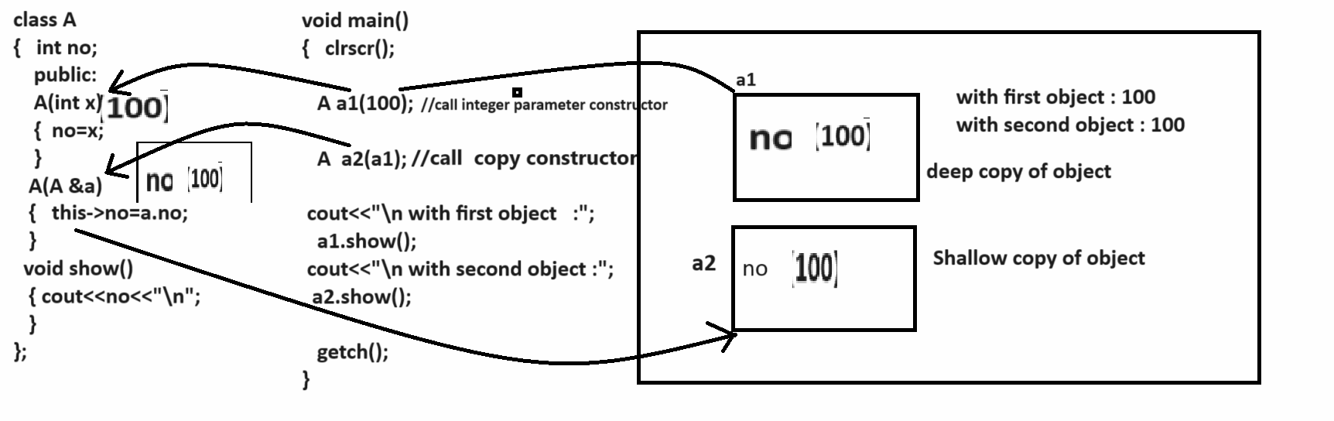

Example: WAP to create class name as Employee with field id,name and salary with constructor
Employee(int id,char name[],int sal): this constructor accept three values as parameter
Employee(Employee &e): this is the copy constructor which help us copy the data of one employee in to another employee object
Example: create two object of employee name as e1 and e2 and copy data of e1 object in to e2 object.
#include<iostream.h>
#include<string.h>
#include<conio.h>
class Employee
{ char ch[90];
int id;
int sal;
public:
Employee(char ch[],int id,int sal)
{
strcpy(this->ch,ch);
this->id=id;
this->sal=sal;
}
Employee(Employee &e)
{ this->id=e.id;
this->sal=e.sal;
strcpy(this->ch,e.ch);
}
void show()
{ cout<<ch<<"\t"<<id<<"\t"<<sal<<"\n";
}
};
void main(){
clrscr();
Employee e1("ABC",1,10000);
Employee e2(e1);
cout<<"\nFirst Employee data\n";
e1.show();
cout<<"\nSecond Employee data\n";
e2.show();
getch();
}
5. Dynamic constructor: dynamic constructor means if we call constructor by using new keyword called as dynamic constructor

Syntax: classname *ref = new classname();
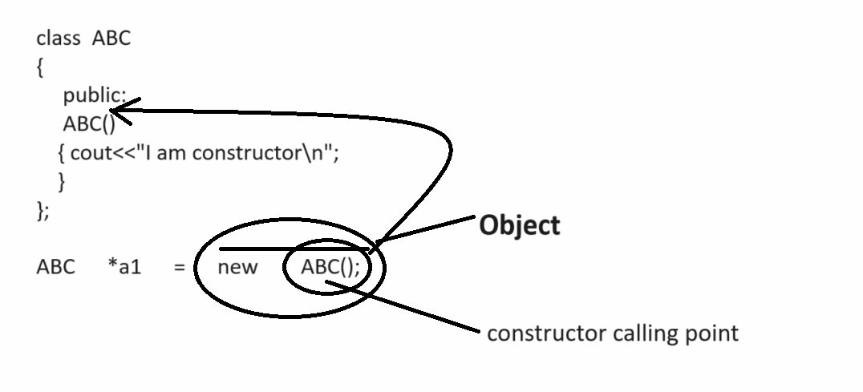
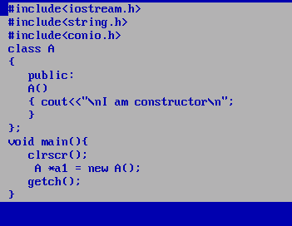

Q. what is diff between malloc and new?
_____________________________________________________________________
if we use the malloc keyword then no constructor calling happened or malloc function not call constructor and if we use the new keyword then constructor get executed
